EXPERIMENT 5(a)

5a.Simulation and Performance Evaluation of RFID/NFC-Based Device Identification and IoE Data Integration using Node-RED, MQTT.

1. Objective
- To design and simulate an RFID/NFC-based device identification system using Node-RED and MQTT.
- To identify devices using unique RFID/NFC tag IDs and integrate their data into an IoE system.
- To establish communication between devices and the MQTT broker for data transmission.
- To evaluate system performance based on identification accuracy, message delivery, and communication latency.
2. Procedure
1. Install the required software: Install Node.js, Node-RED, and the Mosquitto MQTT broker.
2. Configure the MQTT broker: Start Mosquitto and configure MQTT nodes in Node-RED to publish and receive messages through a common topic.
3. Simulate RFID/NFC identification: Create sample RFID/NFC tag IDs, such as RFID001, RFID002, and RFID003, using Inject nodes or simulated input data in Node-RED.
4. Process device IDs: Use a Function node to read the received tag ID, check whether the device is registered, and generate its identification status.
5. Integrate IoE data: Combine the device ID with information such as device name, timestamp, and status to create a structured message.
6. Publish data using MQTT: Send the processed device information to an MQTT topic using an MQTT Out node.
7. Receive and display data: Use an MQTT In node to receive messages and a Debug or Dashboard node to display the identified device details.
8. Test device identification: Send multiple registered and unregistered device IDs and verify whether the system correctly identifies them.
9. Evaluate performance: Measure identification accuracy, message delivery rate, and communication latency based on the simulation output.

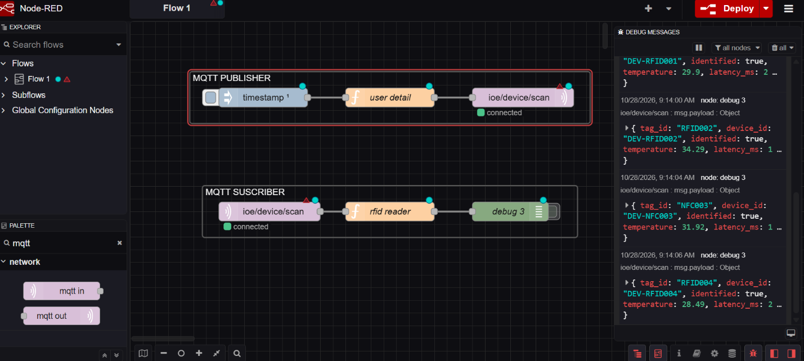

3. Result
The RFID/NFC-based device identification and IoE data integration system was successfully modelled using Node-RED and MQTT. Simulated device IDs were processed to determine their identification status, and the associated data was transmitted through the MQTT broker and displayed in Node-RED. The experiment demonstrated device identification, message exchange, and integration of device information within an IoE framework. The system's identification accuracy, message delivery rate, and communication latency can be evaluated using the simulation results.

